Employee Data Analysis and Supervised Machine Learning Model Comparison
AI Pioneers Internship (Machine Learning) - Yuva Intern
Submitted by: Varshana

1. Introduction
In this project I worked on a machine learning task using Python. The goal was to predict the salary of an employee using details like age, experience, education level, department and city. I used a sample employee dataset that I created for practice. This project helped me understand the full flow of a machine learning task, from cleaning the data to comparing two models.

2. Tools and Libraries Used
- Python 3
- Pandas and NumPy for handling and cleaning the data
- Matplotlib for drawing graphs
- Scikit-learn for preprocessing, model training and evaluation

3. Dataset Description
The dataset has 300 employees and 7 columns: employee_id, age, experience_years, department, city, education_level and salary. I added some missing values and 6 duplicate rows on purpose, so that I could practice data cleaning. The column to predict (target) is salary.

4. Data Preprocessing
- Removed the 6 duplicate rows, so 300 unique rows were left.
- Filled missing age values with the median, and missing experience values with the mean.
- Filled missing city values with the most common city (mode).
- Dropped the employee_id column because it does not help in prediction.
- Converted the text columns department and city into numbers using one-hot encoding (get_dummies).
- Scaled all the features using StandardScaler so the values are in a similar range.

5. Data Visualization
I made some graphs to understand the data better. The first graph shows how the salaries are spread, and the second graph shows that salary increases when experience increases.
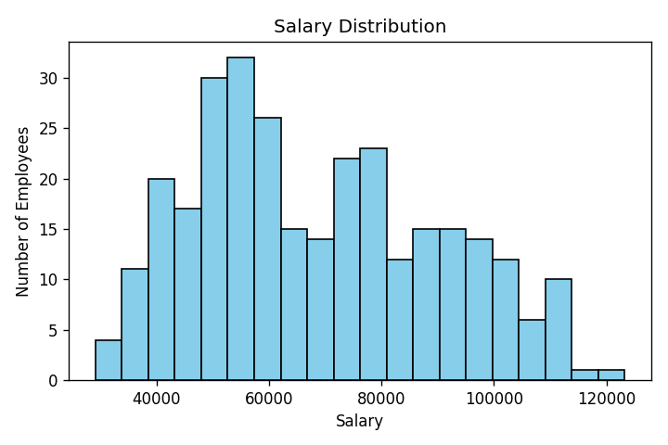
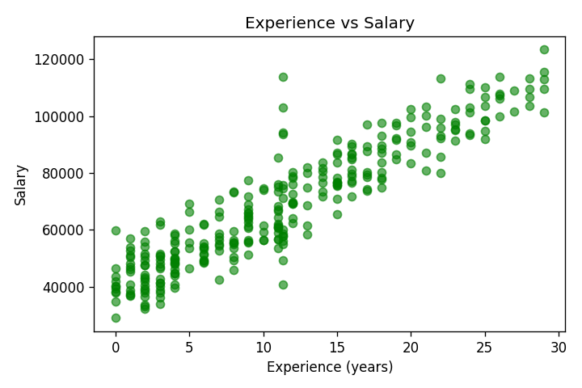

6. Model Building
I split the data into 80% training data and 20% testing data. Then I trained two supervised regression models using Scikit-learn:
- Linear Regression: a simple model that finds a straight-line relationship between the features and salary.
- Decision Tree Regressor (max_depth = 5): a model that makes decisions by splitting the data into branches.

7. Results and Comparison
I checked both models on the test data using Mean Squared Error (MSE), Root Mean Squared Error (RMSE) and R2 score. Lower error and higher R2 means a better model.
Model | MSE | RMSE | R2 Score
Linear Regression | 46,859,240 | 6,845.38 | 0.9056
Decision Tree | 92,679,750 | 9,627.03 | 0.8133

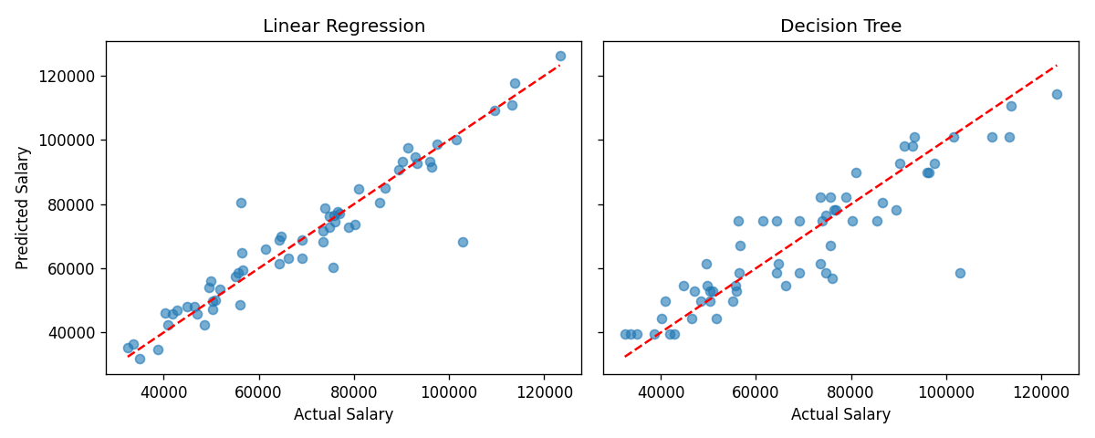
Linear Regression gave the better result, with an R2 score of 0.9056 compared to 0.8133 for the Decision Tree. This is because in my dataset the salary depends on experience and education in an almost straight-line way, so a simple model fits well.

8. Conclusion
From this project I learned that data preprocessing is a very important step before building any model. I also learned that we should always compare more than one model, because the best model depends on the data. This task improved my Python skills with Pandas, NumPy and Scikit-learn, and I also learned how to upload a project on GitHub. In the future I want to try real-world datasets and more algorithms like Random Forest.

9. GitHub Link
https://github.com/varshanaravichandran/ml-internship-project

